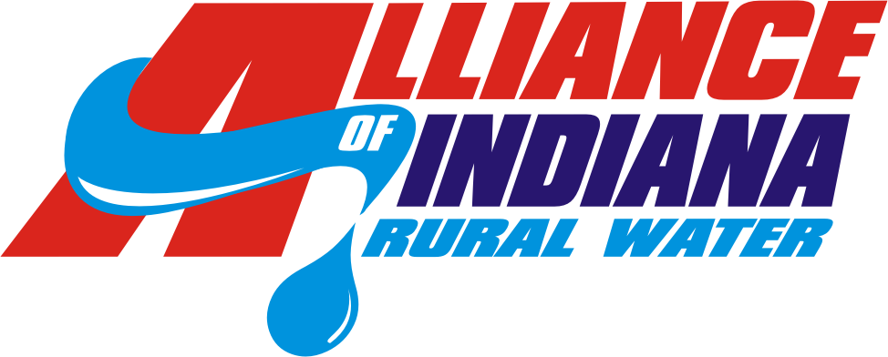

2019 Salary Survey

please read before proceeding
Due to a demand for more current Salary and Benefits Information from the water and wastewater industry in Indiana, we are once again gathering data from our members so that we may produce another Salary Survey Report. If you are not the individual with access to your organization’s salary and benefits data, we ask that you please forward this survey to that individual so that your utility may be included in the survey data.
Please review the survey prior to inputting any information. There are specific instructions for each section on the first couple of pages. These will help you understand what information will be gathered and how to report information for certain sections as you move forward. It will be most efficient for you to gather all the information you will need prior to inputting the data into the survey. The actual data entry portion of the survey should take you very little time.
When handling the document attached, please download or save it so that you can utilize its complete functionality. Viewing it in read-only, or in protected view may cause a skew in the visibility of the Form, and it will not allow you to answer our questions properly. When finished, please save it as Salary Survey_"your systems name", before you return the document via email. (e.g. Salary Survey_XYZtown) This will help us refer back to completed forms in a faster and more efficient manner.
In order for the finished Salary Survey Report to be completed and handed out by the last week of August, we ask that your system could please return this completed form to this email address, alliance@inh2o.org, by Monday, June 10th.
The Alliance truly thanks you for your participation, time, and effort in our 2019 Indiana Water and Wastewater Salary Survey. Every response is critical in the reporting of accurate compensation packages, we thank you for helping us in this effort.

2019 Salary Survey
The Alliance of Indiana Rural Water (AIRW) first created and supplied its members with a salary survey in the year 2008, then again in 2015. The purpose behind this year’s salary survey is to provide our members with a representation of the different jobs offered in the water utilities industry and their corresponding compensation and benefits. Systems will be classified according to the number of connections and the congressional district in which the system resides. This will help systems to compare their size and region with other systems of a similar size and region. A third classification will be used to compare the different certifications an operator might hold and its corresponding change in annual gross salary.
In order to improve the validity of the survey, the Alliance of Indiana Rural Water hopes that your system would be willing to participate and return this survey so that the data may be calculated for results. As an incentive to return complete and accurate data, members who complete this survey by the requested deadline, June 10th, will receive a free copy of the finished survey report. Additional copies of the report may be purchased for $100 each.

Salary Survey Instructions
This survey contains questions that may have confidential answers. The individual who is completing this survey should have access to any confidential material which might be used to answer any questions completely and truthfully. Confidential material may include: employee’s annual gross salary and benefits information, system identification and utility information, and the governing bodies compensations information. For easier use of this survey, the underlined headings are hyperlinked to each of their corresponding sections.

Section A - Identification
The information provided in this section is solely to create an identity to use for calculating results. The information will not be published within the completed salary survey report, and will be destroyed upon completion of the survey.
Section B - Utility Information
The information provided in this section will determine which classifications your system will be categorized under. With this information, your system will be able to compare compensation packages with similar systems in regards to size and by region, according to the congressional districts.
Section C – Job Descriptions
The information provided in this section will describe the different jobs offered in the water utilities industry. Since systems may have different titles for each of their jobs, this will allow us to help group jobs under the same title per the description given. In this section, there will be an opportunity to add a position and give a description which may then be added to the final salary survey report given a substantial amount of responses to validate the position. Please be sure that the job(s) you may be adding has not already been described by another job title in our list.
Section D – Salary Information
The information provided in this section will help the Alliance of Indiana Rural Water gather an understanding of the different salary ranges offered as compensation by the respondents. It is important to record an accurate amount of compensation for each job that your system may employ. Further information sought by this section pertains to the highest levels of water and/or wastewater licenses held by the position, years of experience working the position, whether the job is part time or full time, how many hours are worked in a week, if the employee is expected to retire in the next five years, and questions regarding your governing body. For jobs that may have been added, please utilize the option to add rows to include that salary information. For jobs that have more than one employee, please do not record a range of salaries or hourly rates. For accurate reporting please find the average of the employees’ salaries or hourly rates and report that as the compensation for that job. For easier use on the part of the individual completing this form, the jobs in the table are hyperlinked back to their corresponding job descriptions.
Section E – Benefits Information
The information provided in this section lists the different types of benefits that may accompany a job working with a water and/or wastewater utility system. It is important to be as accurate as possible when recording the amount of benefits given to an employee employed by your system. Other information sought in this section will include days off, whether the benefit is offered to full-time and/or part-time, or both, whether the amount of days off increase with time employed by the system, and lastly, to what extent job training may be compensated. In this section, there will be an opportunity to add a benefit and give a description which may then be added to the final salary report given a substantial amount of responses to validate the benefit.
Section F – Uniforms, Equipment, and Vehicle Information
The information provided in this section lists the different type of equipment, clothing, and vehicular benefits a water and/or wastewater utility system may offer to their employees. This section covers the different types of equipment offered, laptop, tablet, phone, and/or any other special equipment required to finish a job, how they may be used, and if the company provides compensation for their costs. It also covers compensation for uniforms, and any costs associated with using a vehicle, owned by the company or not. In this section, there will be an opportunity to add a type of benefit that may be categorized under this section and may then be added to the final salary report given a substantial amount of responses to validate the piece of equipment.
Section G – Comments and Feedback
Please utilize this section to help us gather your opinions on the survey and how it may be improved or changed to provide members with more useful information.

Section A - Identification
Name of Utility:
PWSID #:

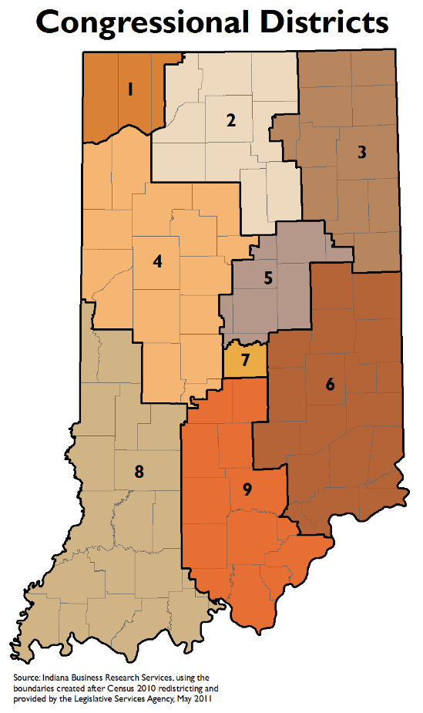
Section B - Utility Information
Congressional District: Select a District
County: Select a County
Type of Utility:
☐Water ☐Wastewater ☐Water and Wastewater
Type of Ownership:
☐District ☐Municipality ☐Privately Owned
Water Source:
☐Ground ☐Surface ☐Combination ☐Purchase Only
Number of Active Residential Water Meters:
Number of Active Commercial Water Meters:
Number of Active Residential Wastewater Meters:
Number of Active Commercial Wastewater Meters:
Number of Water Customers:
Number of Wastewater Customers:
Number of Full-Time Employees: Number of Part-Time Employees:
Annual Operating Budget: Annual Revenue:
Click to Return to the Salary Survey Instructions
Number of Townships Covered: Miles of Water Lines:
Percentage of Revenue spent on Payroll, including salaries and benefits:
Percentage of Revenue spent on Training Employees:

Section C – Job Descriptions

General Manager/Superintendent (GM/SI):
The general manager is responsible for office and field administration, planning, reporting and policy administration. The general manager is responsible for planning, directing, and coordinating services, activities and operations of all facilities, equipment, and projects under their supervision. The general manager is also responsible for determining the amount and type of compensation packages and the hiring and termination of employees. The general manager is also responsible for the utilities’ public relations and must ensure compliance with all laws at the local, state, and federal level. Additionally, the general manager oversees the daily operating activities and may also directly supervise any office, field, or management personnel.

Assistant General Manager/Superintendent (GM/SI):
The assistant general manager reports directly to the general manager and is responsible for any specific tasks assigned by the general manager. The assistant general manager assumes all the duties of the general manager in their absence.

Office Manager:
The office manager is responsible for supervision over all the office activities. The office manager may be responsible for planning and managing projects, as well as, screening and managing callers and office meetings. The office manager must ensure that office standards comply with the local, state, and federal regulations. Lastly, the office manager is responsible for the maintenance and supervision of office equipment and office supplies. For smaller systems, the office manager may be responsible for the duties of the billing and payroll clerk, as well as other administrative duties.

Clerk Treasurer:
The Clerk Treasurer is responsible for administrative work regarding the city/county’s daily business activities and must act as a liaison to the city/county’s legislative body. This may include preparing the city/county’s budget and agendas for council meetings, being held accountable for receipts regarding the city/county’s transactions, preparing financial reports, records the meeting minutes and maintains ordinances, conducts research so council members can make an informed decision, and is responsible for payroll for the city/county officials. The clerk treasurer is also responsible for many other clerical and financial duties, but duties may differ by city/county.

Administrative Assistant:
The administrative assistant is responsible for providing administrative support to their direct supervisor. Examples of administrative support may include, but not limited to, sending and receiving correspondence, managing the distribution of information within the office, and other necessary clerical duties.

Billing Clerk:
The billing clerk is responsible for creating invoices and gathering numerical data to provide a bill to customers who have rendered the system’s goods and/or services. The billing clerk is also responsible for ensuring that the invoice matches what the system provided and to whom.

Click to Return to the Salary Survey Instructions

Bookkeeper (Accountant):
The bookkeeper is responsible for recording the system’s daily financial transactions and maintaining financial accounts. These duties include the accurate recording of payments, purchases, sales, and receipts made by the system. The bookkeeper may also be responsible for creating financial reports. The bookkeeper is not required to possess an accounting certificate.

Utility Service Worker (Laborer):
Utility service workers are responsible for grounds keeping, installing meters, repairing defects in the water system infrastructure, and performing excavations to determine the nature and extent of damage or leaks within the water system. The utility service worker may also be referred to as the assistant to the water and/or wastewater operators.

Water Operator:
The water operator is responsible for operating, monitoring, and maintaining the water treatment facility. The water operator is also responsible for the treatment and quality of water being distributed to consumers. The water operator may work with engineers, chemists, and laboratory staff in order to ensure the system is working correctly and efficiently. The water operator is also responsible for the maintenance, repair, construction, and installation of water systems. Additionally, the water operator may be responsible for using instruments to locate water lines and test backflow devices and water mains. In Indiana, the water operator must hold the corresponding water treatment certification or greater for the system it is operating. If the operator is distributing water then it must hold a certification for that as well.

Wastewater Operator:
The wastewater operator is responsible for operating, monitoring, and maintaining the wastewater treatment facility. The wastewater operator is responsible for treating and removing any impurities, solids, or toxins from the water and ensuring that the chemical, physical, and biological levels are in accordance with local, state, and federal requirements before it returns to a natural body of water. The wastewater operator is also responsible for ensuring the system is working correctly and efficiently by monitoring and repairing any defects within the process. In Indiana, the wastewater operator must hold the corresponding or greater wastewater certification for the system it is operating. If the operator is distributing the water then it must hold a certification for that as well.

Field Manager (Plant Operator):
The field manager is responsible for managing the day-to-day operations of water and/or wastewater systems. The field manager is also responsible for ensuring that the water and/or wastewater operations are meeting the required standards set by regulatory targets. The field manager is responsible for overseeing employees and ensuring that all tasks are being completed correctly and efficiently. Additionally, the field manager may respond to emergencies regarding the operations of the water and/or wastewater and ensuring the safety of all employees under their supervision.

Click to Return to the Salary Survey Instructions

Maintenance Technician:
The maintenance technician is responsible for performing technical work in the maintenance and repair of the water and/or wastewater collection and/or distribution facilities. The maintenance technician is responsible for performing preventive and corrective maintenance, repairing and installing different components of the water and/or wastewater systems. The maintenance technician is also responsible for creating and coordinating a schedule for work of maintenance contractors in support of projects. Additionally, the maintenance technician may be responsible for maintaining and creating reports detailing the operations of the water and/or wastewater systems.

Foreman:
The foreman is responsible for the supervision and coordination of personnel working on projects to help improve or repair the water and/or wastewater systems. The foreman is responsible for conducting training and in-service of supervised personnel and provides equipment as needed by the personnel to complete their project. Additionally, the foreman is responsible for reviewing daily logs of progress and must respond to customer complaints regarding projects. The foreman is responsible for the promotion, discipline, and termination of personnel.

Meter Reader:
The meter reader is responsible for traveling to different connections, reading water meters and recording the consumption of water for that connection. The meter reader is also in charge of reporting meter defects and detecting unlawful use of water, illegal connections. In Indiana, a meter reader must have a high school education and an acceptable driving record.

Laboratory Technician:
The laboratory technician is responsible for testing the quality of water by measuring how much chemical and/or biological matter is in the water. The laboratory technician may work with a chemist, microbiologist, and/or the water treatment operators to ensure the quality of water is abiding by the local, state, and federal regulations. The laboratory technician is also responsible for testing for the level of disinfectants and microorganisms and reporting these measured levels to a chemist, microbiologist, and/or the water treatment operator.

Option to Add Job:
Add your own description here

Option to Add Job:
Add your own description here

Option to Add Job:
Add your own description here
Click to Return to the Salary Survey Instructions

Section D – Salary Information
Job | # of  Employees in position |  | Rate of Pay? (Provide a $ Amt. Per Hour or an Annual Salary) |  |  | Water License Level |  | WW License Level |  | Highest  Edu.  Level |  | Yrs  Of Exp |  | Is Employee Eligible to Retire within 5 years? (Y/N) |  | PT  or  FT | Work Week (Hrs/Wk)
GM/SI
Asst. GM/SI
Office Manager
Clerk Treasurer
Admin. Asst.
Billing Clerk
Bookkeeper (Accountant)
Utility Service Worker (Laborer)
Water Operator
Wastewater Operator
Field Manager (Plant OP)
Maintenance Tech.
Foreman
Meter Reader
Lab Tech.
Option to Add
Option to Add
Option to Add

Governing Body
If your system has more than one governing body please list details for both for each question.
Name(s) of the governing body(ies):
Members in the governing body(ies):
Meetings per year:
Do members get paid a bonus for special or emergency meetings? If yes, what is the amount?
How do members obtain their position? ☐Election ☐Appointed ☐ Other
If other, please describe:
Click to Return to the Salary Survey Instructions
Position | # in Position | Is compensation per meeting, annual, weekly, or other? If other, please describe | Compensation
President
Vice-President
Secretary/Treasurer
Member/Trustee

Section E – Benefits Information

Insurance & Retirement
Type of Insurance | Provided by Employer? (Y/N) | If Y, what % is Covered by Employer? | Insurance Covers Employees Family? (Y/N) | If Y, what % is covered by Employer? | Provided to FT, PT, or Both?
Health
Medical
Life
Dental
Vision
Retirement |  |  | X

Days Off & Miscellaneous Benefits
Type of Benefit | Provided by Employer? (Y/N) | If Y, How Many Days per Year? | Do the Amt. of Days Increase with Employment?  Is there a Maximum? | If Y, what are the Increases?  What is the Max. Amt? | Provided to FT, PT, or Both? | Is Employee  Compensated for Training? (Y/N) | If Y, What % is Covered by Employer?
Paid Vacation |  |  |  | Increases:  Maximum: |  | X | X
Paid Holidays |  |  |  | Increases:  Maximum: |  | X | X
Paid Sick Leave |  |  |  | Increases:  Maximum: |  | X | X
Short-Term Disability |  |  |  | Increases:  Maximum: |  | X | X
Long-Term Disability |  |  |  | Increases:  Maximum: |  | X | X
Comp Time |  | X | X | X |  | X | X
Overtime Pay |  | X | X | X |  | X | X
Paid Training |  | X | X | X
Personal Time Off |  |  |  | Increases:  Maximum: |  | X | X
Option to Add |  |  |  | Increases:  Maximum:
Option to Add |  |  |  | Increases:  Maximum:
Option to Add |  |  |  | Increases:  Maximum:
Option to Add |  |  |  | Increases:  Maximum:
Option to Add |  |  |  | Increases:  Maximum:

Section F – Uniforms, Equipment, and Vehicle Information
Type of Benefit | Provided by Employer (Y/N) | If Y, May it be Used Personally? (Y/N) | % of Cost Covered by Employer | Provided to FT, PT, or Both? | Is Gas Reimbursed?  If Y, what %?
Company Laptop |  |  |  |  | X
Company Phone |  |  |  |  | X
Company Vehicle
Uniforms |  |  |  |  | X
Company Tablet |  |  |  |  | X
Option to Add
Option to Add
Option to Add
Option to Add
Option to Add

Section G – Comments and Feedback
Below this sentence, please let us know how we here at the Alliance of Indiana Rural Water should improve this survey in order to make the results more helpful for the members they serve?

Click to Return to the Salary Survey Instructions

